[CEN 323 ] Computer Organization & Assembly Language
Lab 12 Journal

Name :Bilal Aamir
Enrollment Number:01-135232-016

Lab Deliverables (submission guideline)

Create a folder named after your enrollment number and add the following files:
  - Create a folder named YourRollNumber_Lab12 containing:
- .asm files of the 2 practice tasks.
- Add full screen screenshots of the code and output in this word file.
  - Zip the Folder and upload to LMS.

Lab Task

Task 1:
Code (TEXT):
INCLUDE EMU8086.INC
ORG 100H

.STACK 100H

.DATA
ARR1 DW 1,2,3,4,5
ARR2 DW 6,7,8,9,1
COUNT DW 5
RESULT1 DW 5 DUP(?)
RESULT2 DW 5 DUP(?)

.CODE

COPYARRAY PROC
PUSH BP
MOV BP, SP

MOV CX, [BP+4]
MOV DI, [BP+6]
MOV SI, [BP+8]

STORELOOP:
MOV AX, [SI]
MOV [DI], AX
ADD SI, 2
ADD DI, 2
LOOP STORELOOP

POP BP
RET 6
COPYARRAY ENDP

MAIN:

PUSH OFFSET ARR1
PUSH OFFSET RESULT1
PUSH COUNT
CALL COPYARRAY

PUSH OFFSET ARR2
PUSH OFFSET RESULT2
PUSH COUNT
CALL COPYARRAY

MOV AX, 4C00H
INT 21H

Screenshot (CODE):
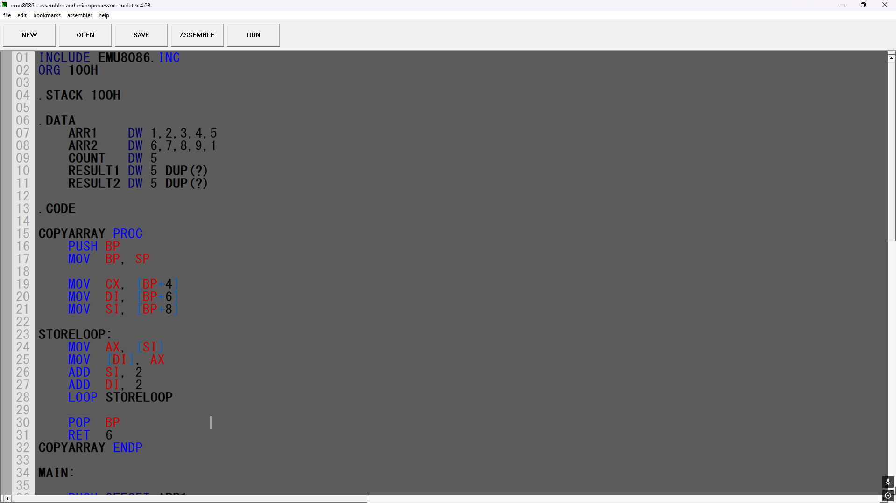

Screenshot (OUTPUT):
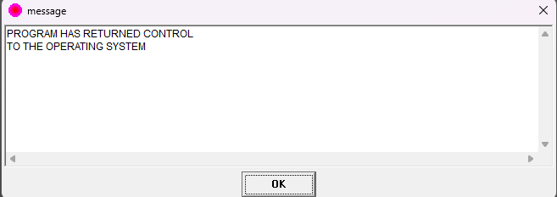

Task 2:
Code (TEXT):
INCLUDE EMU8086.INC
.STACK 100H

.DATA
ARR1 DW 1,2,3,4,5
ARR2 DW 6,7,8,9,1
COUNT DW 5
MSG1 DB 'ARR1 replacements: $'
MSG2 DB 'ARR2 replacements: $'

.CODE

REPLACEVAL PROC
PUSH BP
MOV BP, SP
SUB SP, 2
MOV [BP-2], 0

MOV CX, [BP+6]
MOV SI, [BP+8]
MOV DX, [BP+4]

SCANLOOP:
MOV AX, [SI]
CMP AX, DX
JNE SKIP

MOV [SI], 0
INC [BP-2]

SKIP:
ADD SI, 2
LOOP SCANLOOP

MOV AX, [BP-2]

MOV SP, BP
POP BP
RET 6
REPLACEVAL ENDP

MAIN:
MOV AX,@DATA
MOV DS,AX

PUSH ARR1
PUSH COUNT
PUSH 3 ;
CALL REPLACEVAL

MOV AH, 09H
MOV DX, OFFSET MSG1
INT 21H
ADD AL, '0'
MOV DL, AL
MOV AH, 02H
INT 21H
PRINTN ""

PUSH OFFSET ARR2
PUSH COUNT
PUSH 9
CALL REPLACEVAL

MOV AH, 09H
MOV DX, OFFSET MSG2
INT 21H
ADD AL, '0'
MOV DL, AL
MOV AH, 02H
INT 21H
PRINTN ""

MOV SI, OFFSET ARR1
MOV CX, 5

PRINT_R1:
MOV AX, [SI]
ADD AL, '0'
MOV DL, AL
MOV AH, 02H
INT 21H
MOV DL, ' '
MOV AH, 02H
INT 21H
ADD SI, 2
LOOP PRINT_R1
PRINTN ""

MOV SI, OFFSET ARR2
MOV CX, 5
PRINT_R2:
MOV AX, [SI]
ADD AL, '0'
MOV DL, AL
MOV AH, 02H
INT 21H
MOV DL, ' '
MOV AH, 02H
INT 21H
ADD SI, 2
LOOP PRINT_R2

MOV AX, 4CH
INT 21H

END MAIN
Screenshot (CODE)
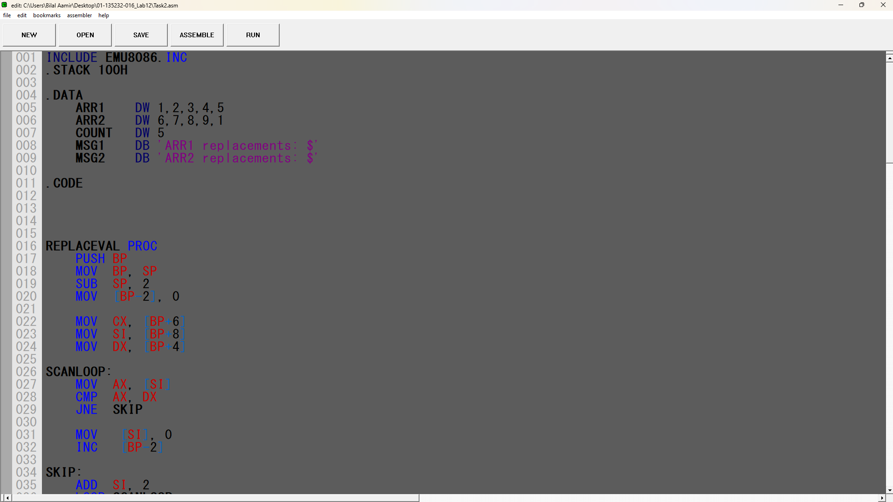
Screenshot (OUTPUT):
